Monte Carlo March 28th - Meeting Minute

Updates from Colleen:

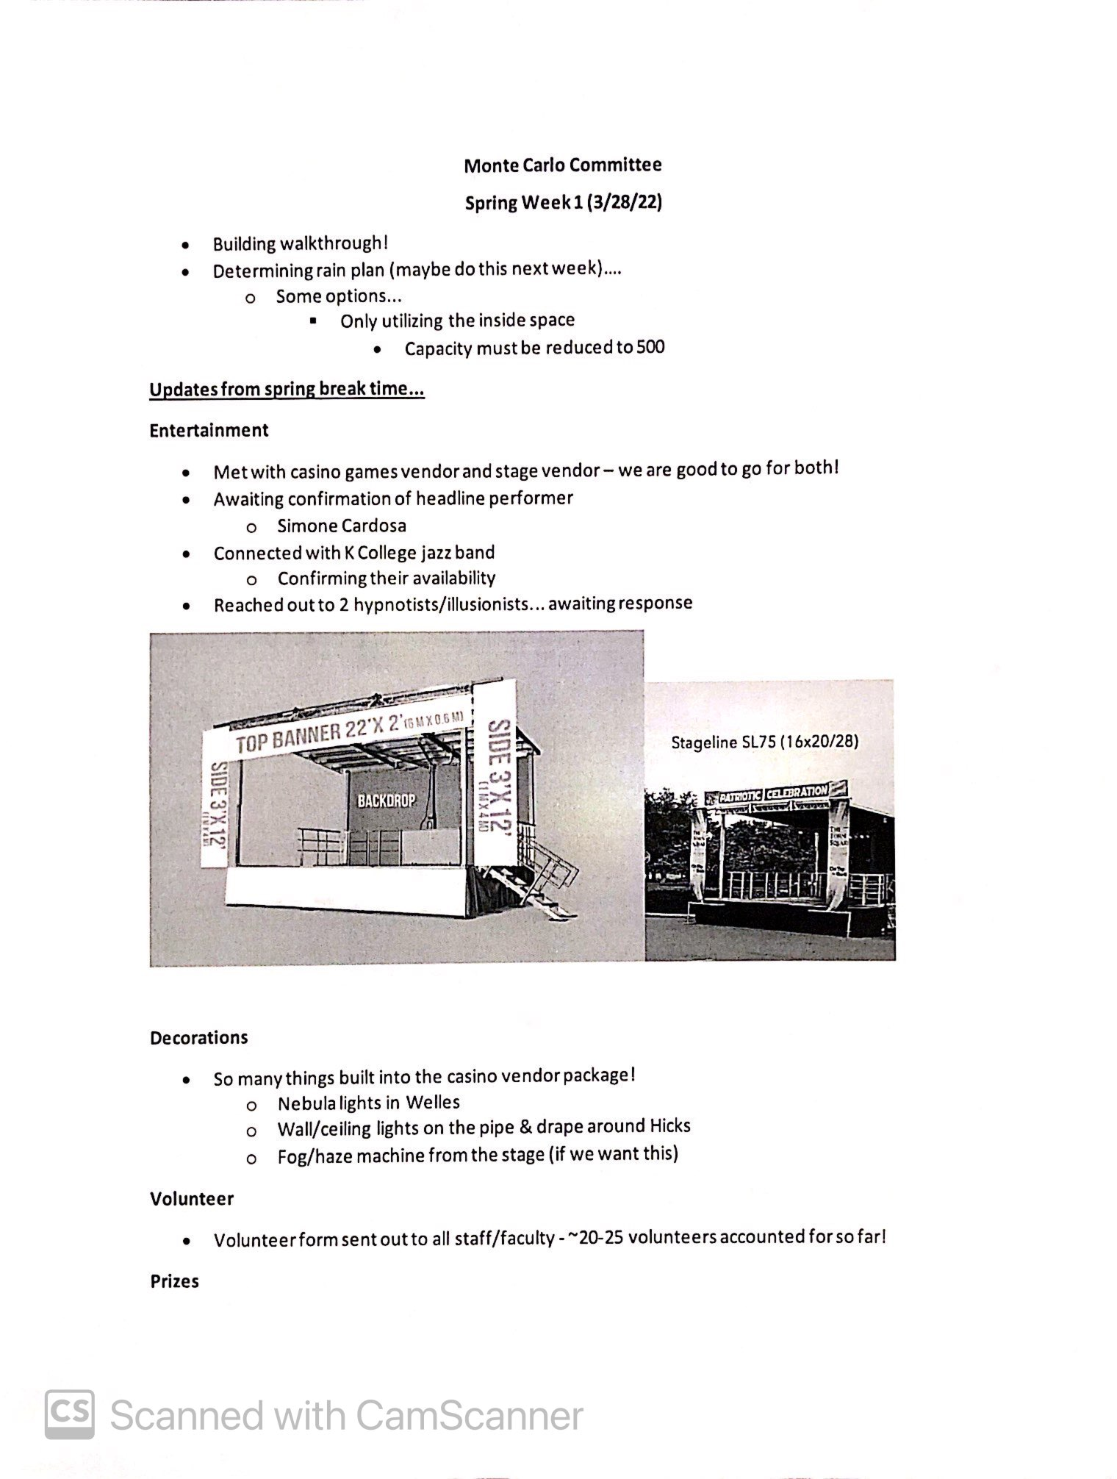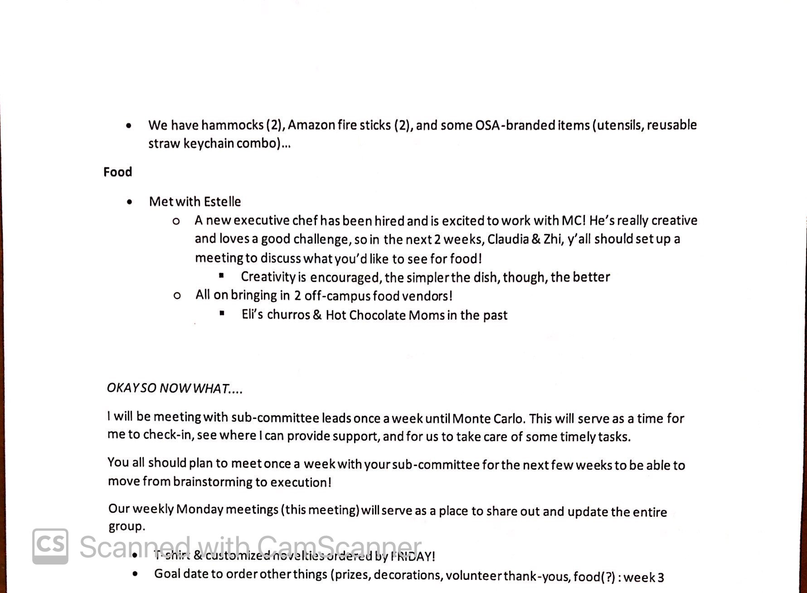

Other updates from other committees:

Entertainment commitee:

-We can get large glow sticks

**SHIRT DESIGN - JORENCE:** Shirt Design is in Teams channel. The 1st design is planned to be the volunteer’s shirt, and the 7th design is planned to be the committee’s shirt. Designs are made for the front of shirt and have the same color as on file.

Prizes Commitee:

Monte Carlo Pre-Meeting Notes 3/28/2022:

* How many chips do we have/ do we need to buy chips?
  + We were thinking of doing each worth 50 (meaning we would need like 40,000 chips) or like 100 (meaning we would need like 20,000 chips)
  + These numbers are very adjustable and we can find room in the budget to buy more chips if necessary
* Once we have a good quantity of prizes we will determine how much they will cost
  + How much are the large prizes usually worth? Small prizes?
* We also plan on having lunches with Jorge and Malcolm where 6 people can win a lunch with each person (this lunch will be held in the Wildermuth room at the end of the term)
  + Plan on having it catered with places like Qdoba or Chipotle (easy places)
* TSHIRTS: This year we want to get around 800 t-shirts rather than 600 so more students can have some
  + This means we MUST do short sleeves especially since the event is in may
  + The design should be monochrome (or just limited in colors) so they are cheaper
  + Would we like sponsorships for the back of it? (local businesses pay like 50 dollars to get their logo on the back or something)
  + We have $4,000 set aside right now for them but we have some room to add funds (about 500 more dollars or so)
* Space Pens: If anyone knows where to buy these in bulk that would be great since I am having trouble finding the ones mentioned in the previous meeting
* Anything else that needs to be done?